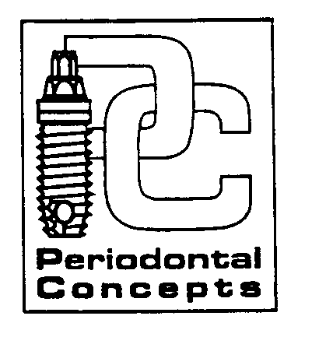
INSTRUCTIONS FOLLOWING PERIODONTAL SURGERY
Soft Tissue Graft – Connective Tissue Graft – Pedicle Tissue Graft

We care about you and the success of your surgery. For optimal comfort and healing your utmost in post-surgical cooperation is required.

BLEEDING: You may expect minor oozing for up to 24 hours after surgery, this is normal. If heavy or prolonged bleeding occurs, contact us immediately.

SWELLING: Swelling is normal following periodontal surgery, however due to the very delicate nature of your graft, please do not ice the area.

MEDICATIONS: Take your prescriptions as instructed. Take medications with food to lower the chance of nausea. Avoid alcohol and do not operate heavy equipment or motor vehicles while taking prescription pain medications. To best control post-operative discomfort, take pain medication before the numbness wears off. If you become sick, or a rash develops, contact us immediately. Women on birth control pills should use alternative contraception while taking antibiotics.

FLUIDS: Drink plenty of fluids for the next few days. Avoid using a straw for the first 72 hours following surgery. Suction forces in the mouth encourage bleeding.

DIET: Eat nourishing foods that are soft and cool for the first 24-48 hours. Examples include blended fruits and vegetables, cottage cheese, instant breakfast, applesauce, yogurt, etc. Do not chew in the area of the procedure for the first two weeks. Avoid gum and hard, sticky or small seed foods that could traumatize and injure the surgical site.

ACTIVITY: Rest is essential for successful recovery. Please rest the day of your procedure and reduce your activities for the next few days. Avoid running or strenuous activity for 3-4 days.

HOMECARE: WEEK ONE: Gently rinse your mouth with warm salt water (1/4 tsp. to 8 oz. water) after each meal. Use the prescribed rinse morning and night, gently rinsing for 30 second. After rinsing, brush and floss the other areas of your mouth exercising caution not to injure the surgical site. Avoid any vigorous rinsing for the first 48 hours. WEEK TWO: Continue warm salt water rinses. Clean the surgical site by dipping a cotton swab into the prescribed rinse and gently massage the area. Do not brush the surgical site until instructed.

PALATAL STENT: If a stent was provided it may be worn to minimize discomfort during healing. We recommend wearing it for the first 24-48 hours. You may choose to wear it longer particularly when you eat and sleep to protect the surgical site. Make sure you take it out before rinsing and clean the stent before weaing it again. You may also wear your retainer if it covers the roof of your mouth.

SUCCESS: No smoking (or tobacco products), peroxide or commercial mouth rinses for at least 10 days. Minimizing movement of the surgical site will aid in a successful result. Please minimize talking and smiling for 24 hours and do not stretch your lip or cheek back to look at the surgical site as you may risk movement of the graft and possible failure.

SUTURE/DRESSING: If stitches were placed we will remove them at your post-op visit in approximately 2 weeks. It is normal for sutures to become loose. We will advise you on how to care for the area at this appointment.

If you have any questions regarding your surgical procedure, please, do not hesitate to contact our office.

Office (360) 254-8151, or in case of emergency, Dr. Derhalli: (360) 241-3664

